**Papers written by**

**Australian Maths Software**

**REVISION 1**

**2016**

**SEMESTER 2**

**MATHEMATICS**

**APPLICATIONS**

**Units 1 & 2**

**SOLUTIONS**

SECTION **1 – Calculator-free**

**Question 1 (8 marks)**

(a) (i) “Place of birth” is nominal ✓

as there can be a number of places of birth, but there is no intrinsic ranking as in ordinal numbers. ✓

(ii)

|  |
| --- |
| 9 |
| 8 |
| 7 |
| 6 |
| 5 |
| 4 |
| 3 |
| 2 |
| 1 |

(ii)

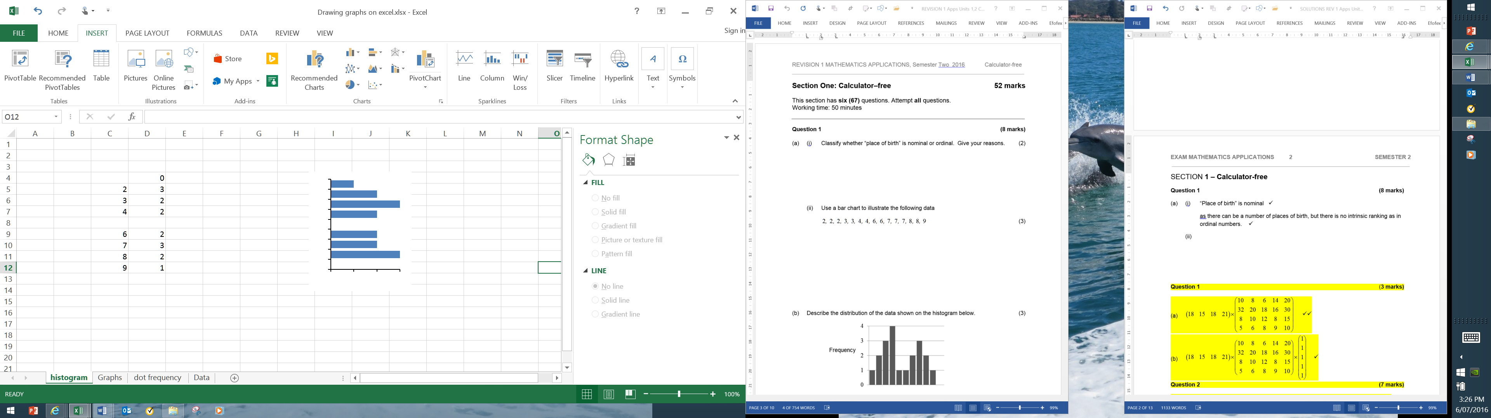

✓✓✓

|  |  |  |
| --- | --- | --- |
| 1 | 2 | 3 |

(b) The distribution is bi-modal. Scores are clustered around two different scores. There

seems to be no outlier. Most of the scores are high or low with not too many in the middle.

✓✓✓

**Question 2 (7 marks)**

(a)  These two matrices cannot be added as they are a different size. ✓✓

(b)  ✓✓

(c)  ✓

(d)  ✓✓

**Question 3 (9 marks)**

(a) (i)  ✓✓

(ii)  ✓✓

(b)

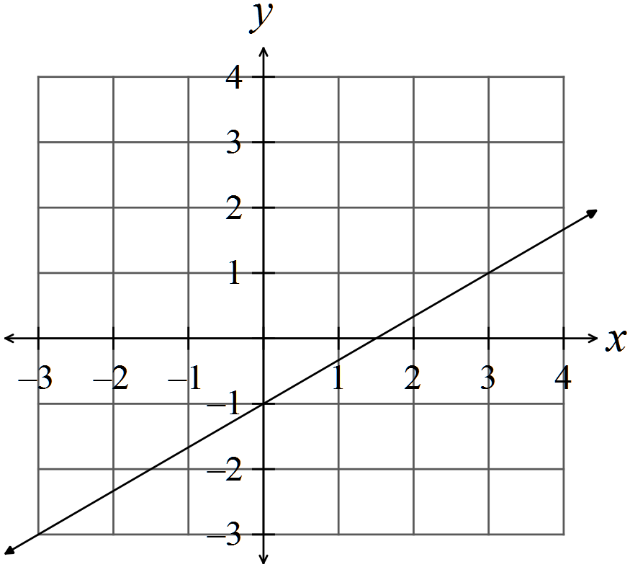✓✓

(c)  ✓

(d)  ✓✓

**Question 4 (12 marks)**

(a)  ✓✓

(b)  ✓✓

(c)

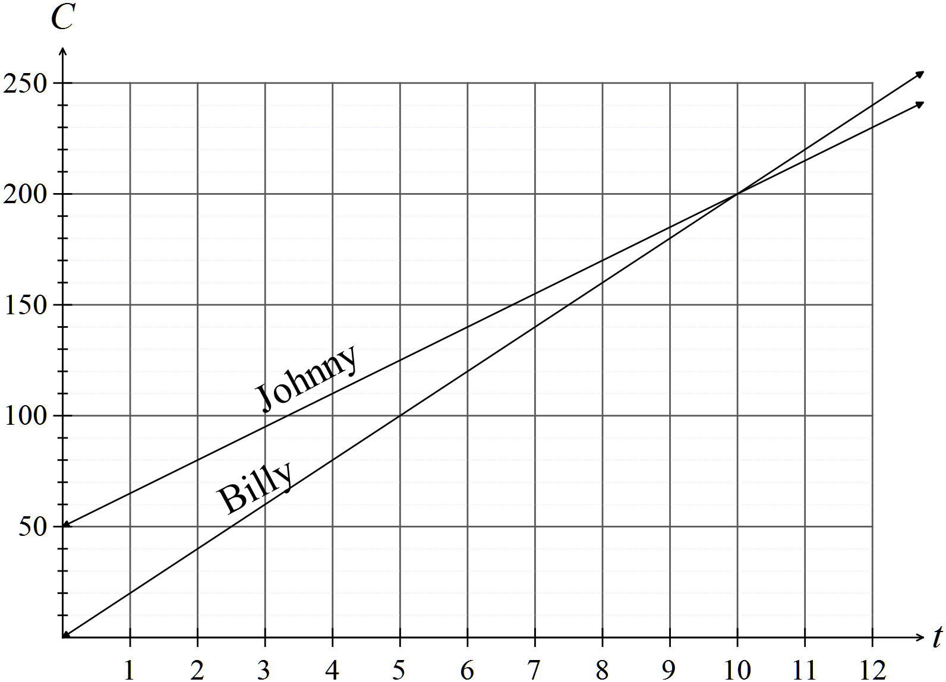

✓✓

✓✓

(d)  ✓

 Billy s the cheaper gardener for 7 hours work. ✓

(e) Costs are the same for 10 hours work. ✓✓

**Question 5 (10 marks)**

(a) Range = 7 – 0 = 7 ✓ Median = 2 ✓ IQR = 5.5 – 1 = 4.5 ✓

(b) Any two of

The mean, standard deviation, variance, mode ✓✓

(c) Set 1 has a range of 7 whereas set 2 has a range of 5. ✓ Set 2 may have outliers.

Set 1 has an IQR of 4.5 whereas set 2 has an IQR of 2, so the middle 50% of set 2 is more tightly clustered. ✓

Set 1 has 25% of scores between 1 and 2 and the next 25% of the scores between 2 and 5.5, The median of set 1 is at 2, so the data is skewed to the right whereas the median of set 2 is in the middle of the middle 50% of scores which means that it is possible for set 2 to have low outliers. ✓✓✓

**Question 6 (6 marks)**

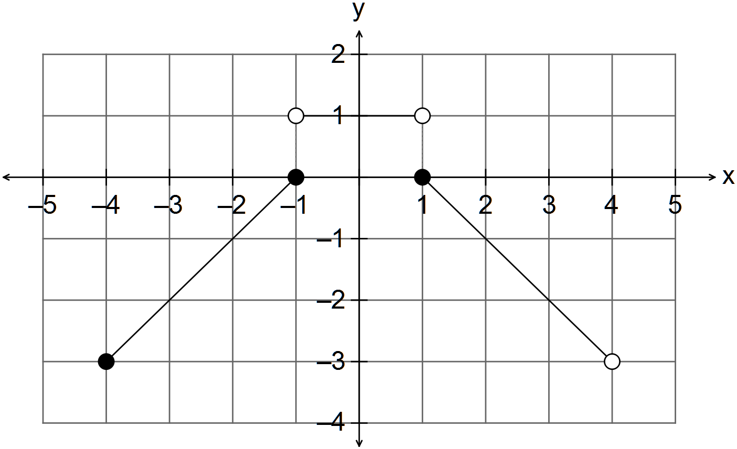

✓

✓

✓

✓

✓

✓

**END OF SECTION ONE**

**SECTION 2 – Calculator-assumed**

**Question 7 (7 marks)**

✓✓

(a) 

✓ ✓

(b)  ✓

✓ ✓

**Question 8 (8 marks)**

(a) (i)  ✓

(ii) 9, 10, 11 ✓✓

(iii)  ✓ ✓

(b)

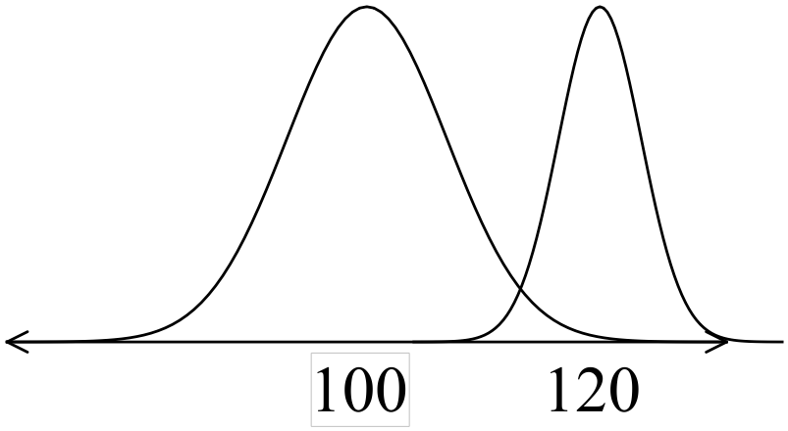✓✓✓

**Question 9 (5 marks)**

(a)  ✓✓

 ✓

(b)  ✓✓

i.e. $2222

**Question 10 (9 marks)**

(a) Jim $20 x 30 + 2 x 1.5 x $20 = $600 + $60 = $660

✓ ✓

James $16 x 40 = $640 ✓

Jim earns $20 more ✓

(b) (i) Rent $350 Phone $40

Car $250 Electricity $90

Food $120 Gas $60

Entertainment $40 $190  ✓

$760 ✓

Therefore total per week is $803.85 ✓

(ii) 

✓ ✓

**Question 11 (7 marks)**

(a) Coles  ✓

Woolworths  ✓

Woolworths is the cheaper buy. ✓

(d) (i) $130x0.80 = $104 ✓✓

(ii) Profit = $14 ✓

Profit % =  ✓

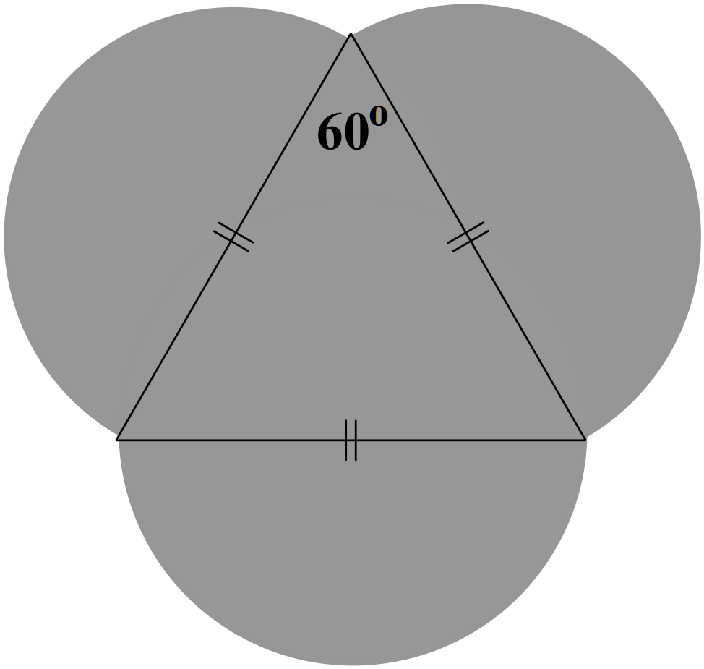**Question 12 (16 marks)**

(a) Area = area of triangle + 1.5 area of circle



✓

✓ ✓

✓

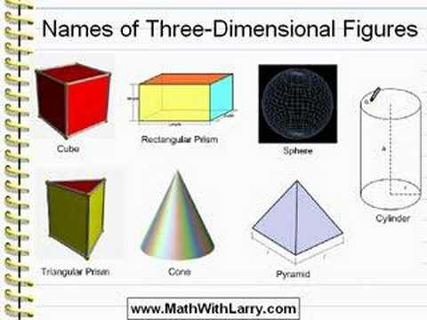(b)



✓

✓ ✓

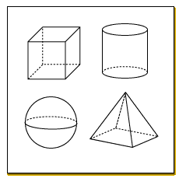

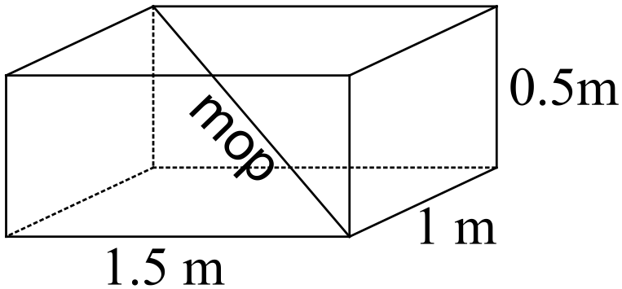(c) 

Yes, the 1.7 m mop will fit in the boot.

(d) 

✓ ✓ ✓

(e) (i)  ✓

(ii) Weight depends on volume.

 ✓ ✓

**Question 13 (21 marks)**

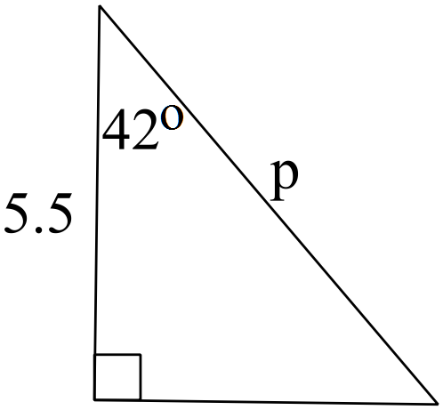(a) (i)  ✓



✓

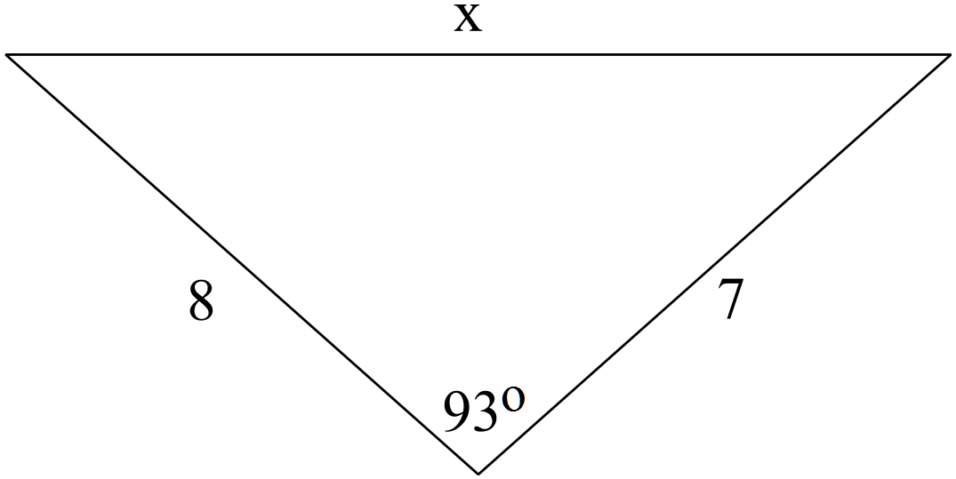

(ii) 

✓



✓

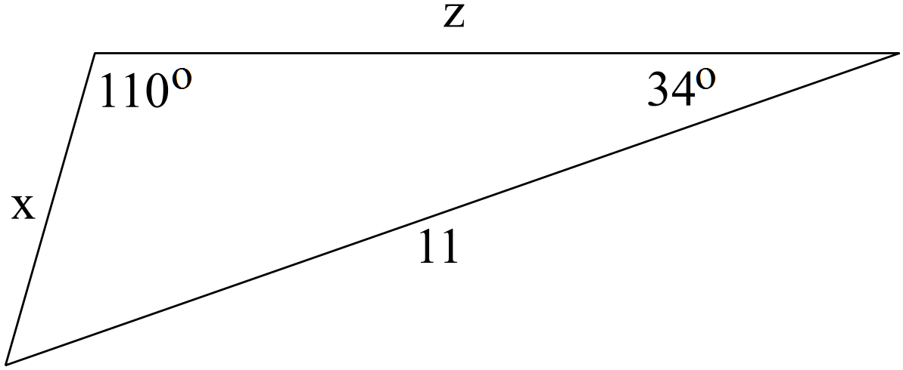

✓

(iii) 

✓

✓

 

(b) (i)

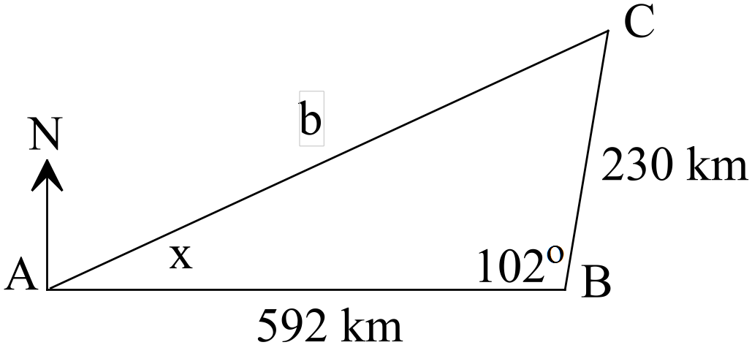

✓✓✓

✓

✓

(ii) 



✓

✓

Ken had to fly 678 km back to Perth

(iii) 

✓

✓

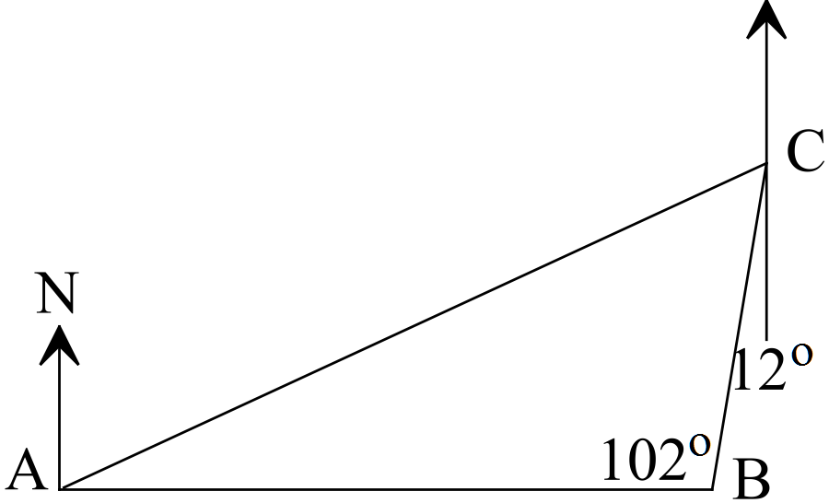

✓

The direction is 

✓

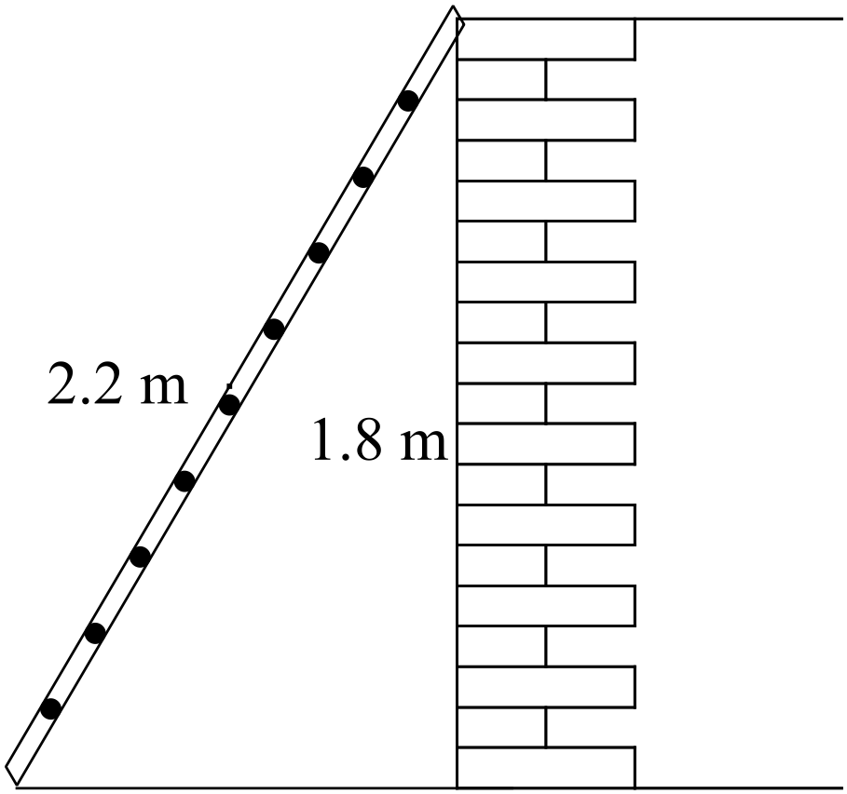(c) (i) 

✓✓

✓

(ii) 



✓

✓

**Question 14 (5 marks)**

Let x = cost of Big Mac

Let y = cost of can of coke

3x + 4y = 22.43 x 2 ✓

2x + 5y = 19.62 x -3 ✓

6x + 8y = 44.86

-6x - 15y = -58.86

-7y=-14

y = 2 ✓

2x + 10 = 19.62

2x = 9.62

x = 4.81 ✓

Therefore a Big Mac costs $4.81 and a can of coke costs $2. ✓

**Question 15 (6 marks)**

✓



✓

✓

✓

✓

**Question 16 (15 marks)**

(a) (i)  ✓✓

(ii)  ✓✓

(iii)  ✓✓

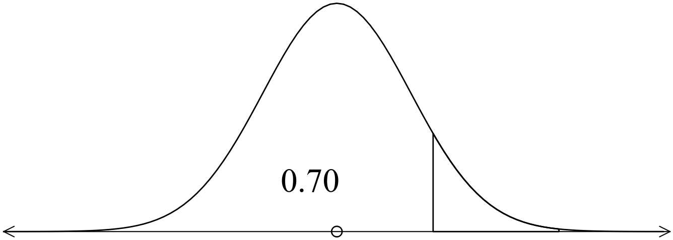 (iv)  ✓✓✓

(b) (i) English



✓✓

Mathematics



✓✓

Damon did relatively better as he was 1.2 standard deviations above the mean

whereas Jenny was 0.5 standard deviations above the mean.

(ii) English 

Mathematics

✓

✓

He did better in Maths.

**End of solutions**